Ahmedabad Institute of Technology
Affiliated to Gujarat Technological University
Approved by AICTE


DEPARTMENT OF MASTER OF COMPUTER APPLICATION

Research work Project Phase-II Report On
“E-Commerce Website ShopEase (Django)”

Submitted as Partial Fulfilments of Master of Computer Application Sem-IV

Developed By

Singh Aayush Vedpraksh (245850694048)
Vegada Sangita Babubhai (245850694052)
Chauhan Bhumika kishorbhai (245850694004)

Under the Guidance of

Prof. Niki Patel

Faculty of Computer Applications

AIT - Beside Vasant Nagar Township, Gota Ognaj Road, Off Gota Cross Road, Ahmedabad, Gujarat, 380060.

Ahmedabad Institute of Technology
DEPARTMENT OF MASTER OF COMPUTER APPLICATION

CERTIFICATE

This is certified that

Singh Aayush Vedpraksh (245850694048)
Vegada Sangita Babubhai (245850694052)
Chauhan Bhumika kishorbhai (245850694004)

Students of MCA Semester IV
Have successfully completed the Research work Project Phase-2 Report On

“E-Commerce Website ShopEase (Django)”

As a partial fulfilment of the study of

Master of Computer Application

Asst Prof. Niki Patel Asst Prof. Dhaval Khatri
(Internal Guide) (HOD)

Faculty of Computer Application

21 February 2026

AIT - Beside Vasant Nagar Township, Gota Ognaj Road, Off Gota Cross Road, Ahmedabad, Gujarat, 380060.
INDEX
No. | Section | Page
1 | Introduction | 3
2 | Problem Statement | 4
3 | Objectives | 5
4 | Scope | 6
5 | Literature Review / Market Survey | 7
5.1 | Literature Review | 7
5.2 | Market Survey | 8
6 | System Analysis | 9
6.1 | Existing System | 9
6.2 | Proposed System | 10
6.3 | System Architecture Diagram | 11
7 | System Design | 12
7.1 | ER Diagram | 12
7.2 | Database Schema | 13
7.3 | Use Case Diagram | 17
7.4 | Data Flow Diagram (DFD) | 18
7.5 | Activity Diagram | 20
7.6 | Sequence Diagram | 21
8 | Proposed Solution / Methodology | 22
9 | Tools / Technologies / Hardware | 25
10 | Module Description | 27
11 | Implementation Details | 30
12 | Security Architecture | 33
13 | Tentative Timeline and Work Plan | 35
14 | Expected Outcomes | 37
15 | Ethical, Legal & Environmental Considerations | 38
16 | Testing | 40
17 | Conclusion & Bibliography | 42

1. Introduction
ShopEase is a full-stack e-commerce web application developed using the Django web framework (Python 3.13.2) with MySQL as the relational database backend. The platform is designed to bridge the gap between buyers and sellers through a structured, role-based digital marketplace. In today's rapidly evolving digital economy, e-commerce platforms play a crucial role in connecting businesses with consumers across geographies and market segments.
ShopEase supports three distinct user roles — Customer, Seller, and Super Admin — each with a dedicated interface and a clearly defined set of functionalities. The application is built on Django's Model-View-Template (MVT) architecture, ensuring clean separation of concerns, maintainability, and scalability across all modules.
Sellers can independently list products, manage inventory, track orders, and create discount campaigns. Customers can browse products using category filters and search, manage a session-based shopping cart without logging in, apply discount codes, and place orders through a Cash-on-Delivery checkout flow. The Super Admin retains full platform oversight including seller approval, customer management, product moderation, and order management.

1.1 Key Technical Highlights
- Session-based authentication with SHA-256 password hashing using Django's make_password() and check_password()
- Django ORM for SQL injection prevention through parameterized queries — zero raw SQL used
- CSRF token enforcement on all form submissions across all templates
- Session-driven cart stored as {product_id: quantity} — no login required to add items
- Configurable DiscountCode engine supporting percentage and flat discount types with expiry, usage limit, and minimum order value validation
- Responsive Bootstrap 5 UI with navy (#0D1B3E) and orange (#F5A623) theme
- Role-Based Access Control (RBAC) enforced through session checks in every view function

1.2 Project Context
The project is developed under the guidance of Asst. Prof. Niki Patel as part of the MCA Semester IV curriculum at the Ahmedabad Institute of Technology, affiliated to Gujarat Technological University. The entire application has been developed, tested, and deployed locally with plans for cloud deployment in the next phase.

2. Problem Statement
The rapid growth of digital commerce has created strong demand for e-commerce platforms that are not only feature-rich but also secure, scalable, and easy to manage for multiple types of users. However, many existing small-scale solutions suffer from critical shortcomings that limit their effectiveness and adoption.

2.1 Identified Problems
- Single-Role Systems: Most entry-level systems lack proper role-based access control. A flat-access model makes it impossible to separate responsibilities of customers, sellers, and administrators, leading to security vulnerabilities and poor user experience.
- No Seller Autonomy: Sellers often have no independent interface to manage products and orders without admin intervention, creating bottlenecks and reducing seller efficiency.
- Poor Cart Management: Session management and cart functionality are often handled poorly, resulting in data inconsistencies. Many systems require login before adding items to cart, reducing conversion rates.
- Missing Discount System: Many platforms lack a built-in discount and coupon management system, limiting promotional campaign capabilities for sellers.
- Security Vulnerabilities: Security mechanisms such as CSRF protection and SQL injection prevention are frequently neglected. Plain-text password storage poses serious security risks.
- Non-Responsive UI: Fixed-width layouts break on mobile devices, reducing accessibility and usability for a significant portion of users.
- No Order Tracking: Customers cannot view order history or status after placing an order, leading to poor post-purchase experience.

ShopEase directly addresses all these gaps by implementing proper role-based access, seller self-service, discount management, secure session handling, and a clean responsive Bootstrap 5 interface within a maintainable Django-based architecture.

3. Objectives
The primary objectives of the ShopEase project are defined across technical, functional, and security dimensions:

3.1 Functional Objectives
- Develop a Multi-Role E-Commerce Platform: Design and implement a complete web application supporting three distinct user roles — Customer, Seller, and Super Admin — each with dedicated dashboards and clearly defined access privileges enforced through session-based role checks.
- Build a Seller Panel with Full Product Management: Enable sellers to independently add, edit, and delete products with image upload (Pillow), manage stock levels, view all orders received for their products, and update order statuses from pending through to delivered.
- Implement Session-Based Cart System: Develop a shopping cart that uses Django server-side sessions to persist cart data as {product_id: quantity} without requiring user login, supporting quantity adjustments, item removal, and real-time price calculation including 5% GST and shipping logic.
- Create a Discount Code Engine: Implement a DiscountCode model allowing sellers to generate coupon codes with configurable discount type (percentage or flat), discount value, minimum order value, expiry date, and usage limit with used_count tracking.
- Build a Super Admin Management Panel: Provide a dedicated admin dashboard with platform-wide statistics, seller approval and deletion, customer management, product moderation, and order management.

3.2 Technical Objectives
- Implement Secure Authentication: Build a session-based login and registration system with SHA-256 password hashing, role-based redirect on login, logout functionality, and CSRF protection across all form submissions.
- Ensure Database Security via Django ORM: Leverage Django's Object-Relational Mapper for all database queries to inherently prevent SQL injection through parameterized queries.
- Design a Responsive Professional UI: Build a fully responsive front-end using Bootstrap 5 with a consistent navy blue (#0D1B3E) and orange (#F5A623) color theme, ensuring usability across desktop and mobile devices.
- Implement Order Management: Complete order lifecycle including placement, confirmation, status tracking, and delivery management across customer and seller interfaces.

4. Scope
The ShopEase project covers the development of a complete web-based e-commerce platform with clearly defined scope boundaries. The following table summarizes the key scope areas:

Table 4.1: Scope Summary Table
Scope Area | In Scope | Details
User Management | ✅ | Customer registration & login, Seller registration with admin approval, SuperAdmin login, session-based authentication for all three roles.
Product & Category | ✅ | Category creation via Django admin, product listing with image upload, stock management, product search by keyword, filter by category.
Shopping Cart | ✅ | Session-based cart (login not required), add/remove/update items, quantity controls, real-time subtotal, 5% GST, free shipping above ₹499, grand total.
Seller Panel | ✅ | /seller/ dashboard stats, product CRUD, seller orders list, order status update, discount code management.
Discount System | ✅ | Percentage and flat discount codes, minimum order value, expiry date, usage limit and used_count tracking, apply/remove at cart.
Order Management | ✅ | Checkout with address form or saved addresses (COD), order creation, confirmation page, My Orders page with status badges.
Admin Panel | ✅ | /admin-panel/ with seller approval/deletion, customer list/delete, product list/delete, all orders with status update.
Security | ✅ | CSRF tokens on all forms, SHA-256 password hashing, session management, Django ORM parameterized queries to prevent SQL injection.
Payment Gateway | 🔄 Planned | Razorpay integration — planned for Phase III.
Real-time Notifications | 🔄 Planned | Push notifications for order status updates — planned for Phase III.
Face Recognition Login | 🔄 Planned | OpenCV + dlib face recognition for customer login — planned for Phase III.
Mobile App | ❌ | Out of scope — web only for current phase.

5. Literature Review / Market Survey
5.1 Literature Review
A review of existing literature and similar platforms helped identify the core requirements and architectural decisions for ShopEase. The following areas were studied in depth:

Django as a Web Framework for E-Commerce
Django is a high-level Python web framework following the Model-View-Template (MVT) architectural pattern. Its built-in ORM, admin interface, form handling, and security middleware make it well-suited for e-commerce applications. Django's parameterized query system through the ORM effectively prevents SQL injection attacks, while its CSRF middleware guards against cross-site request forgery by generating and validating a unique token for each form submission. Research consistently shows Django reduces development time by 40-60% compared to lower-level frameworks due to its "batteries included" philosophy.

Role-Based Access Control (RBAC) in Web Applications
Role-Based Access Control is a widely adopted security model where access to resources is determined by a user's assigned role. Research in web application security consistently recommends RBAC as a best practice for multi-user platforms. ShopEase implements a custom RBAC model with three roles — Customer, Seller, SuperAdmin — enforced through session['user_role'] checks in every view function. This approach ensures that no user can access functionality outside their defined role, reducing attack surface and improving UX.

Session-Based Cart Systems
Session management is a standard approach for shopping cart functionality without requiring persistent database storage per interaction. Django's session framework provides a clean API for storing cart data as a Python dictionary {product_id: quantity} in the server-side session, eliminating the need for a separate CartItem database table and allowing cart persistence without login. Industry studies show that requiring login before adding to cart reduces conversion rates by up to 30%.

Discount and Coupon Systems in E-Commerce
Discount management is a key feature of modern e-commerce platforms. Industry implementations highlight the need for configurable discount rules including type (percentage vs. flat), validity period, minimum cart value, and usage limits — all of which are implemented in ShopEase's DiscountCode model with nine configurable fields. Studies show that discount codes increase average order value by 15-25% when minimum order values are set.

Table 5.1: Literature Review Comparison Table
Research Area | Key Finding | Applied in ShopEase
Django ORM Security | Parameterized queries prevent SQL injection by design | All DB operations via ORM — zero raw SQL used
Role-Based Access Control | Separate roles reduce attack surface & improve UX | 3 roles with session-based RBAC in every view
Session Cart Systems | Server-side sessions enable login-free cart persistence | Cart as {product_id:qty} in Django session store
Discount Engine Design | Configurable rules (type, expiry, limit) needed | DiscountCode model with 9 configurable fields
Bootstrap 5 Responsive UI | Mobile-first design essential for modern e-commerce | Full Bootstrap 5 with custom navy/orange theme
Password Security | Hashed storage mandatory — plain text unacceptable | make_password() SHA-256 before every DB write
CSRF Protection | Token-based CSRF prevents cross-site forgery attacks | {% csrf_token %} on every POST form

5.2 Market Survey
A survey of existing e-commerce platforms identified the following market needs and how ShopEase addresses each in comparison to industry giants:

Table 5.2: Existing Platforms Comparison
Feature | Amazon | Flipkart | Meesho | ShopEase
Multi-Role Access | ✅ | ✅ | ✅ | ✅ 3 Roles (Custom RBAC)
Seller Self-Service Panel | ✅ | ✅ | ✅ | ✅ Full CRUD + Dashboard
Session Cart (no login) | ✅ | ✅ | ✅ | ✅ Django Session Store
Discount / Coupon Engine | ✅ | ✅ | ✅ | ✅ Seller-created Codes
COD Payment | ✅ | ✅ | ✅ | ✅ (COD only, Phase I)
Open Source / Custom Built | ❌ | ❌ | ❌ | ✅ Django (BSD License)
SHA-256 Password Hashing | BCrypt | BCrypt | BCrypt | ✅ make_password()
CSRF Protection | ✅ | ✅ | ✅ | ✅ Django CSRF Middleware
Face Recognition Login | ❌ | ❌ | ❌ | 🔄 Planned (Phase III)
Payment Gateway | ✅ Multiple | ✅ Multiple | ✅ Multiple | 🔄 Razorpay Planned

6. System Analysis
6.1 Existing System
Existing small-scale e-commerce solutions commonly suffer from the following limitations which motivated the development of ShopEase:

Table 6.1: Drawbacks of Existing Systems
# | Issue | Description | Impact
1 | Single-Role System | All users have the same access level; no Customer/Seller/Admin separation. | High Security Risk
2 | No Seller Panel | All product management handled by admin only; sellers cannot self-serve. | Operational Bottleneck
3 | Login-Required Cart | Cart data stored in DB tables, requiring login before adding any item. | Reduces Conversion
4 | No Discount System | No built-in coupon management; promotional campaigns are not possible. | Lost Revenue
5 | Weak Security | No CSRF protection, plain-text passwords, raw SQL vulnerable to injection. | Critical Vulnerability
6 | Non-Responsive UI | Fixed-width layouts break on mobile devices; poor small-screen usability. | Poor UX
7 | No Order Tracking | Customers cannot view order history or status after placing an order. | Poor Post-Purchase UX
8 | No Admin Controls | No platform-level controls for seller approval or content moderation. | Platform Quality Risk

6.2 Proposed System
ShopEase proposes a comprehensive solution that directly addresses all identified limitations through modern web development practices and Django's robust framework:

Table 6.2: Proposed System vs Existing System
Feature | Existing System | ShopEase — Proposed
User Roles | Single flat role | Customer / Seller / SuperAdmin with session RBAC
Seller Autonomy | Admin manages everything | Full Seller Panel: product CRUD, orders, discount codes
Cart System | Requires login | Session cart {product_id:qty} — no login needed
Discount System | None | DiscountCode: percentage/flat, expiry, usage limit
Security | Plain text password, no CSRF | SHA-256 hashing, CSRF tokens, Django ORM
UI | Basic non-responsive | Bootstrap 5 responsive, navy/orange professional theme
Order Management | None | Checkout, confirmation, my-orders, seller order updates
Admin Control | Django /admin/ only | Custom /admin-panel/ with seller approval, stats, management
Password Storage | Plain text or MD5 | SHA-256 via make_password() — industry standard
Mobile Support | Not supported | Fully responsive Bootstrap 5 — works on all devices

6.3 System Architecture Diagram — Django MVT Pattern
The diagram below shows the complete Django MVT architecture of ShopEase — from the browser through URL dispatcher, views, templates, models, and down to the MySQL database:

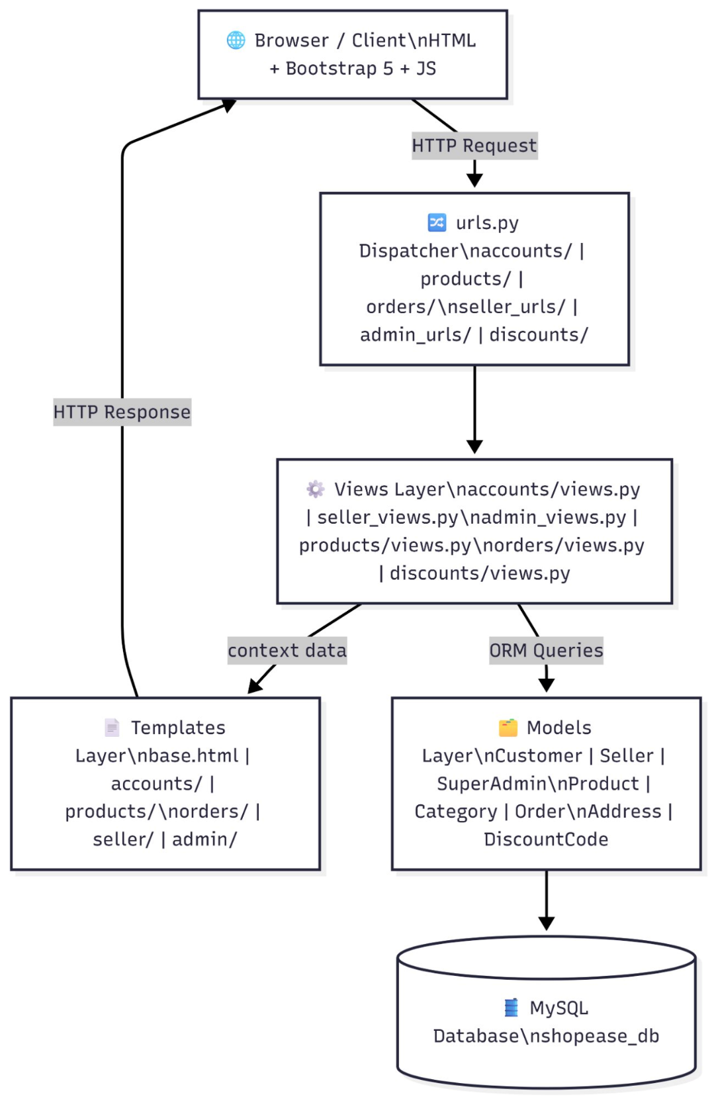
Figure 6.1: System Architecture Diagram — Django MVT Pattern
7. System Design
7.1 ER Diagram
The Entity-Relationship (ER) Diagram below represents the complete database structure of ShopEase. Each entity maps to a MySQL table managed through Django's ORM. Primary keys (PK), Foreign keys (FK), and cardinality relationships are shown. The SuperAdmin has oversight over all entities — Sellers, Customers, Products, and Orders.

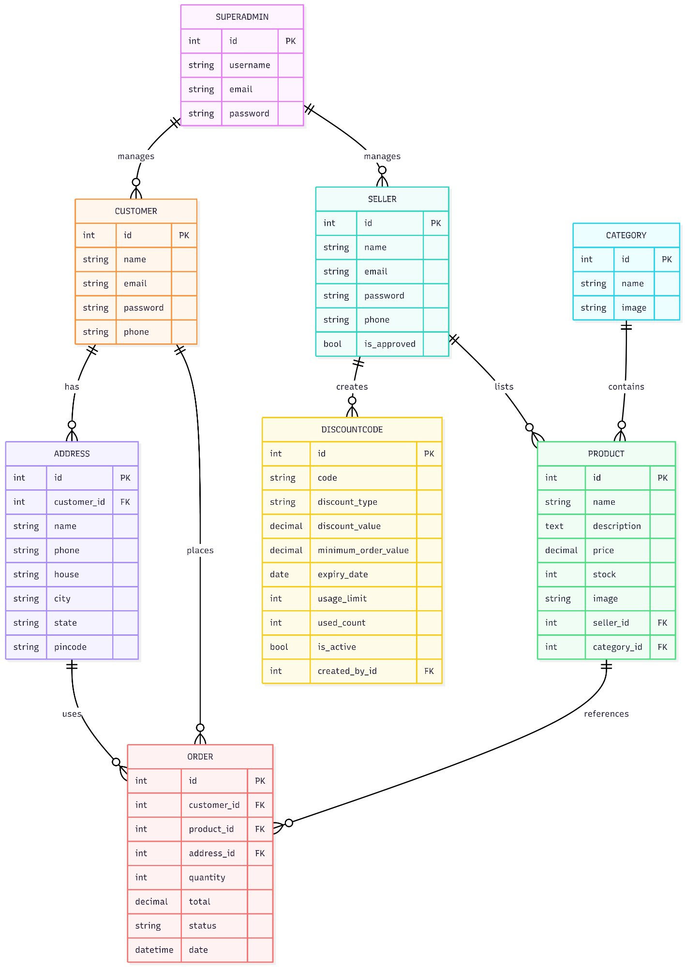
Figure 7.1: ShopEase ER Diagram — 8 Entities with All Relationships
The 8 entities and their key relationships are:
- SUPERADMIN manages SELLER and CUSTOMER (1:N oversight relationship)
- CUSTOMER places ORDER (1:N — one customer, many orders)
- CUSTOMER has ADDRESS (1:N — one customer, many saved addresses)
- SELLER lists PRODUCT (1:N — one seller, many products)
- SELLER creates DISCOUNTCODE (1:N — one seller, many discount codes)
- CATEGORY contains PRODUCT (1:N — one category, many products)
- ORDER references PRODUCT (N:1 — many orders can reference one product)
- ORDER uses ADDRESS (N:1 — many orders can use one address)

7.2 Database Schema
All tables below are stored in MySQL database shopease_db and managed through Django's ORM. Changes are applied using python manage.py makemigrations and python manage.py migrate.
Table 7.1: accounts_customer Schema
Field | Type | Constraint | Description
id | INT | PK, AUTO_INCREMENT | Unique identifier for each customer
name | VARCHAR(150) | NOT NULL | Customer's full name
email | VARCHAR(254) | UNIQUE, NOT NULL | Login email — must be unique across all customers
password | VARCHAR(255) | NOT NULL | SHA-256 hashed password via make_password()
phone | VARCHAR(10) | OPTIONAL (NULL) | Customer contact number (10 digits)

Table 7.2: accounts_seller Schema
Field | Type | Constraint | Description
id | INT | PK, AUTO_INCREMENT | Unique identifier
name | VARCHAR(150) | NOT NULL | Seller / business name
email | VARCHAR(254) | UNIQUE, NOT NULL | Login email — unique across all sellers
password | VARCHAR(255) | NOT NULL | SHA-256 hashed password
phone | VARCHAR(10) | OPTIONAL (NULL) | Seller contact number (10 digits)
is_approved | TINYINT(1) | DEFAULT 0 | 0 = Pending Admin Approval, 1 = Approved

Table 7.3: accounts_superadmin Schema
Field | Type | Constraint | Description
id | INT | PK, AUTO_INCREMENT | Unique identifier
username | VARCHAR(50) | UNIQUE, NOT NULL | Admin username for login
email | VARCHAR(254) | UNIQUE, NOT NULL | Admin email address
password | VARCHAR(255) | NOT NULL | SHA-256 hashed password

Table 7.4: products_category Schema
Field | Type | Constraint | Description
id | INT | PK, AUTO_INCREMENT | Unique identifier
name | VARCHAR(100) | NOT NULL | Category name (e.g. Bikes, Electronics, Clothing)
image | ImageField | OPTIONAL (NULL) | Category image stored in media/categories/

Table 7.5: products_product Schema
Field | Type | Constraint | Description
id | INT | PK, AUTO_INCREMENT | Unique product identifier
name | VARCHAR(200) | NOT NULL | Product name
description | TEXT | OPTIONAL (NULL) | Detailed product description
price | DECIMAL(10,2) | NOT NULL | Selling price in Indian Rupees (INR)
stock | INT | DEFAULT 0 | Available inventory quantity
image | ImageField | OPTIONAL (NULL) | Product image stored in media/products/
seller_id | INT | FK → accounts_seller | Seller who listed this product (CASCADE on delete)
category_id | INT | FK → products_category | Category this product belongs to (CASCADE)

Table 7.6: orders_address Schema
Field | Type | Constraint | Description
id | INT | PK, AUTO_INCREMENT | Unique address identifier
customer_id | INT | FK → accounts_customer | Customer who saved this address (CASCADE)
name | VARCHAR(100) | NOT NULL | Recipient's full name
phone | VARCHAR(10) | NOT NULL | Recipient's contact number (10 digits)
house | TEXT | NOT NULL | House no., building, street, locality
city | VARCHAR(100) | NOT NULL | City / Town name
state | VARCHAR(100) | NOT NULL | State name
pincode | VARCHAR(6) | NOT NULL | 6-digit Indian postal pin code
created_at | DATETIME | AUTO_NOW_ADD | Timestamp when address was first saved

Table 7.7: orders_order Schema
Field | Type | Constraint | Description
id | INT | PK, AUTO_INCREMENT | Unique order ID shown to customer
customer_id | INT | FK → accounts_customer | Customer who placed the order (CASCADE)
product_id | INT | FK → products_product | Product ordered (CASCADE on delete)
address_id | INT | FK → orders_address | Delivery address (SET NULL on delete)
quantity | INT | NOT NULL, DEFAULT 1 | Number of units of the product ordered
total | DECIMAL(10,2) | NOT NULL | Total amount including discount applied
status | VARCHAR(20) | DEFAULT 'pending' | pending / confirmed / shipped / delivered / cancelled
date | DATETIME | AUTO_NOW_ADD | Order placement timestamp

Table 7.8: discounts_discountcode Schema
Field | Type | Constraint | Description
id | INT | PK, AUTO_INCREMENT | Unique discount code record ID
code | VARCHAR(50) | UNIQUE, NOT NULL | Coupon code string (e.g. SAVE10, FLAT50)
discount_type | VARCHAR(20) | NOT NULL | 'percentage' — % off, or 'flat' — fixed ₹ off
discount_value | DECIMAL(10,2) | NOT NULL | Value: 10 for 10% off, or 50 for ₹50 off
minimum_order_value | DECIMAL(10,2) | DEFAULT 0 | Minimum cart subtotal required to apply
expiry_date | DATE | NOT NULL | Date after which code is rejected as expired
usage_limit | INT | DEFAULT 1 | Maximum number of times this code can be used
used_count | INT | DEFAULT 0 | Running count of how many times code has been used
is_active | TINYINT(1) | DEFAULT 1 | 1 = Active (can be applied), 0 = Deactivated
created_by_id | INT | FK → accounts_seller | Seller who created this code (CASCADE)
created_at | DATETIME | AUTO_NOW_ADD | Timestamp when code was created

7.3 Use Case Diagram
The Use Case Diagram below shows all interactions of the three actors — Customer, Seller, and Super Admin — with the ShopEase system. Each actor has a clearly defined set of use cases within the system boundary.

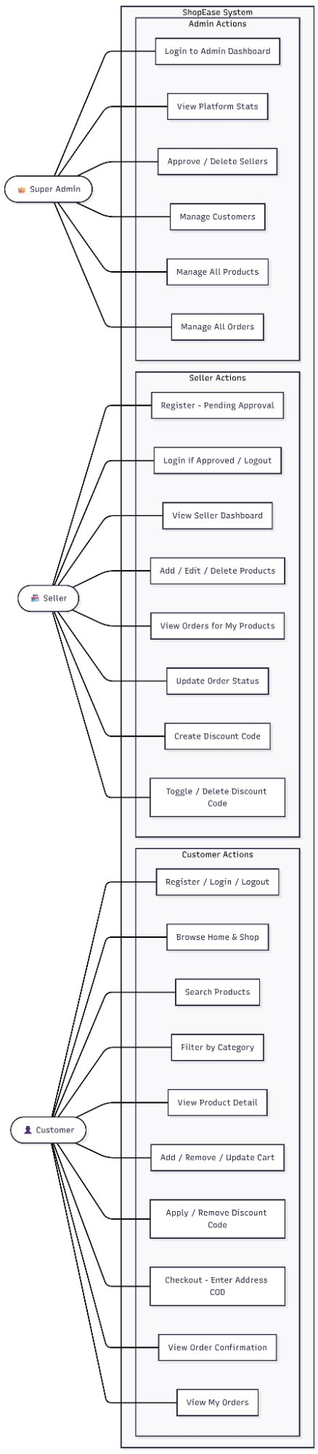
Figure 7.2: Use Case Diagram — Customer, Seller, Super Admin
7.4 Data Flow Diagram (DFD)
DFD Level 0 — Context Diagram
Level 0 shows ShopEase as a single process with all external entities and primary data flows entering and leaving the system. The three external entities are Customer, Seller, and SuperAdmin, all interacting with the central ShopEase system which reads and writes to the MySQL database.
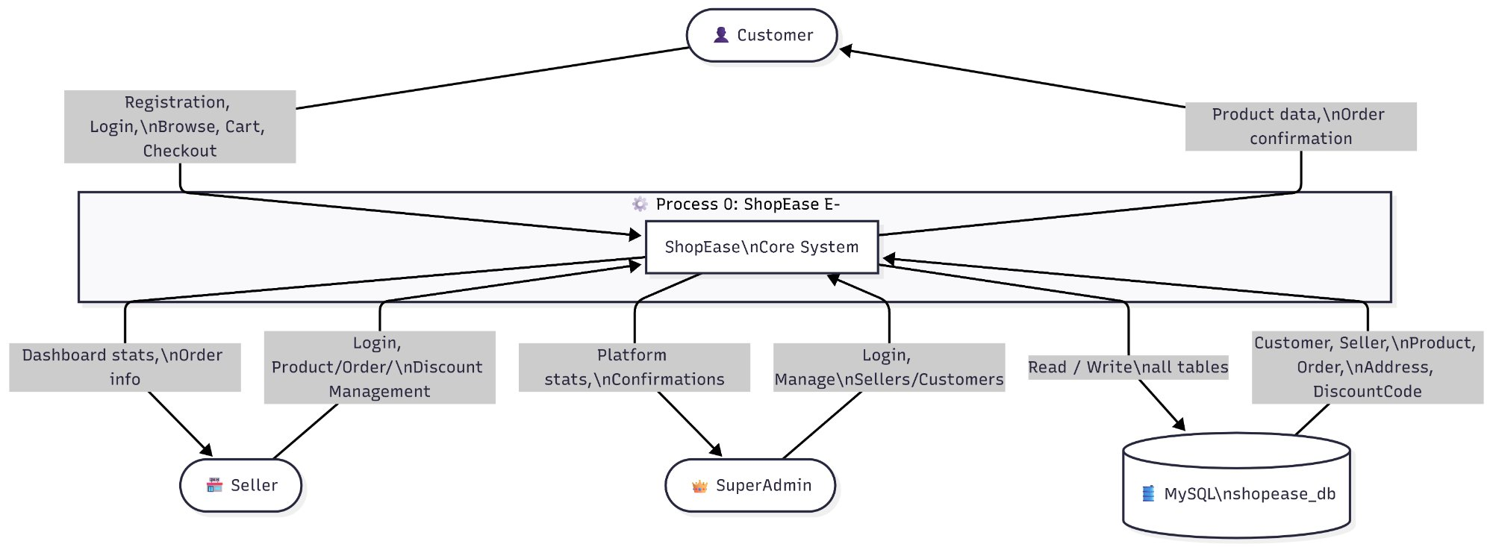
Figure 7.3: DFD Level 0 — Context Diagram

DFD Level 1 — Internal Processes
DFD Level 1 breaks down the ShopEase system into 6 internal processes, each with their own data stores and external entity interactions:
- P1: Authentication — handles login/register for all 3 roles, writes to Session Store
- P2: Cart Management — reads/writes cart dictionary to Session Store
- P3: Discount Validation — validates codes against discounts_discountcode DB, stores discount in session
- P4: Checkout & Order Placement — reads cart, INSERTs to orders_address and orders_order, clears session cart
- P5: Seller Panel — manages products, orders, discount codes in respective DB tables
- P6: Admin Panel — manages seller approvals, customer/product/order records across all models
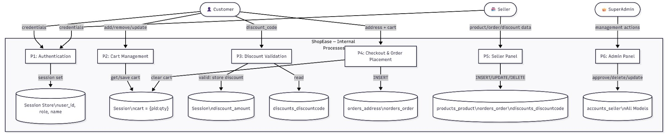
Figure 7.4: DFD Level 1 — ShopEase Internal Processes

7.5 Activity Diagram
The Activity Diagram below shows the complete end-to-end flow for a customer placing an order on ShopEase, from landing on the homepage to receiving order confirmation. Key decision points include Continue Shopping, Apply Discount Code, and Login check.
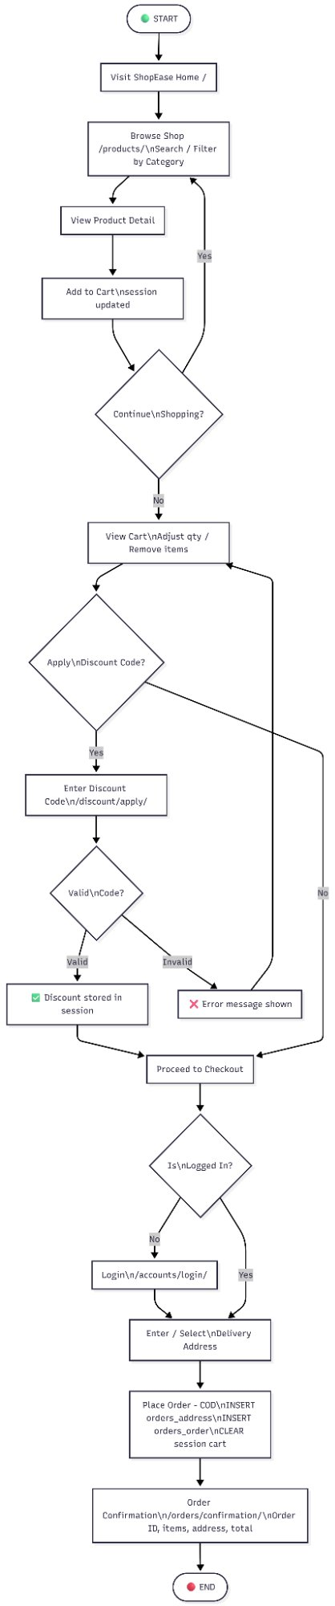
Figure 7.5: Activity Diagram — Customer Order Placement Flow
7.6 Sequence Diagram
The Sequence Diagram shows the chronological message exchanges between the Browser, Django Views, Session Store, and MySQL Database during Login, Cart, and Checkout flows. It demonstrates the exact data flow and timing of operations.
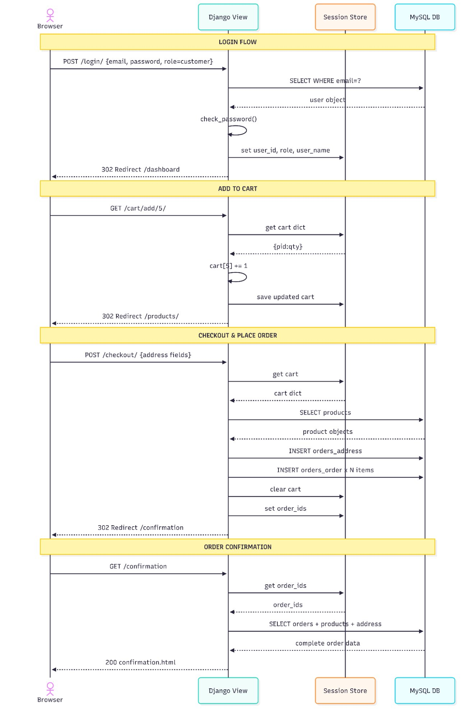
Figure 7.6: Sequence Diagram — Login & Checkout Flow
8. Proposed Solution / Methodology
8.1 Proposed Solution
ShopEase proposes a Django-based multi-role e-commerce platform. The following key architectural components were designed and built:

MVT Architecture
Django's Model-View-Template pattern provides clean separation of concerns. Models in models.py define all database entities using the ORM. Views in views.py handle HTTP request/response logic and business rules. Templates in templates/ render dynamic HTML using the Django template engine with context data passed from views.

Session-Based Authentication
Users log in via /accounts/login/ with email, password, and a 3-tab role selector. On successful check_password() verification, session['user_id'], session['user_name'], and session['user_role'] are stored in the server-side session. Every view checks these session variables to enforce RBAC. Passwords are stored as SHA-256 hashes using make_password() at registration.

Session-Based Shopping Cart
The cart is stored as request.session['cart'] = {product_id: quantity}. Helper functions get_cart(), save_cart(), add_to_cart(), remove_from_cart(), increase_quantity(), decrease_quantity(), and clear_cart() manage all cart operations.
Price calculation logic:
- subtotal = Σ(price × qty)
- tax = subtotal × 0.05 (5% GST)
- shipping = 0 if subtotal > 499 else 49
- grand_total = subtotal + tax + shipping − discount

Seller Panel (seller_views.py)
Dedicated seller interface at /seller/ provides: seller_dashboard_view with stats (product count, order count, total earnings), product CRUD with image upload via Pillow, seller_orders_view filtering orders by the seller's products, and seller_discounts_view for generating, toggling, and deleting discount codes.
Discount Code Engine
DiscountCode model validation checks:
- is_active = True
- expiry_date >= today
- used_count < usage_limit
- cart subtotal >= minimum_order_value
If valid, calculates discount_amount = (subtotal × discount_value / 100) for percentage type, or discount_value for flat type. Stores in session['discount_amount'] and session['discount_code'].
Admin Management Panel
Custom admin interface at /admin-panel/ provides: admin_dashboard_view with platform-wide counts, admin_sellers_view to approve (is_approved=True) or delete sellers, admin_customers_view, admin_products_view, and admin_orders_view with status update dropdown for all orders.

8.2 Methodology — Waterfall Model
The development of ShopEase followed a structured, iterative Waterfall methodology with 8 clearly defined phases. Each phase had specific deliverables and success criteria before moving to the next phase.

Table 8.1: Phase-wise Development Plan
Phase | Activity | Tools Used | Deliverable | Status
1 — Setup | Django project, 4 apps, MySQL config | VS Code, MySQL Workbench | Running dev server + DB | ✅ Done
2 — Models | 8 Django models + migrations | Django ORM | All tables in shopease_db | ✅ Done
3 — Auth | Login/register/logout for 3 roles with sessions | Django sessions, make_password | Secure 3-role auth system | ✅ Done
4 — UI | base.html, home, shop, product detail pages | Bootstrap 5, HTML/CSS/JS | Responsive frontend pages | ✅ Done
5 — Cart/Orders | Session cart, checkout, my-orders | Django sessions, forms | Full customer order flow | ✅ Done
6 — Seller | seller_views.py, discount codes | Django, Pillow, forms | Complete seller panel | ✅ Done
7 — Admin | admin_views.py, seller approval | Django ORM queries | Admin management panel | ✅ Done
8 — Testing | End-to-end all 3 user flows | Browser DevTools | Stable application | ✅ Done

9. Tools / Technologies / Hardware
9.1 Tools Used
Table 9.1: Tools Used in Development
Tool | Version | Purpose
VS Code | 1.90+ | Primary code editor with Django HTML and Pillow extensions
Django Admin Panel | Built-in | Managing categories, superadmin, and DB records during development
MySQL Workbench | 8.0+ | GUI for MySQL — viewing tables, running queries, inspecting data
Git & GitHub | 2.x | Version control and source code backup
Browser DevTools | Chrome/Edge | Frontend debugging, responsive testing, network inspection
Python manage.py shell | Django | Interactive shell for seeding data, approving sellers, testing ORM queries
Postman | Latest | API endpoint testing for view functions
draw.io | Online | System architecture and flow diagram creation

9.2 Technologies & Frameworks
Table 9.2: Technologies & Frameworks Used
Technology | Version | Usage in ShopEase
Python | 3.13.2 | Core backend language — all views, models, utilities
Django | 6.0.1 | MVT framework — ORM, sessions, CSRF, URL routing, admin
MySQL | 8.x | Relational database — shopease_db with 8 tables
mysqlclient | Latest | Python-MySQL connector for Django DATABASES config
Bootstrap | 5.3 | Responsive CSS — grid, cards, buttons, navbar, forms
Bootstrap Icons | 1.x | Icon library used throughout the UI
Pillow | 11.3.0 | Image processing — product and category image uploads
HTML5 / CSS3 | — | Template structure and custom navy/orange CSS styling
JavaScript (ES6) | — | Qty controls (+/−), image preview, address toggle
Django Sessions | — | Server-side session storage for cart and authentication state
SHA-256 (make_password) | — | Secure password hashing via Django's hashers module

9.3 Hardware Requirements
Table 9.3: Hardware Requirements
Hardware | Specification | Purpose
Development Machine | Windows 11, Intel Core i5/i7, 8GB+ RAM | Primary development and testing environment
Storage | SSD (256 GB+) | Fast read/write for Django dev server and MySQL operations
Display | Full HD (1920×1080) | UI design and responsive layout testing
Internet Connection | Broadband | CDN resources (Bootstrap, icons) and pip package installation
Webcam | 720p or higher | Planned: Face Recognition Login — Phase III

10. Module Description
ShopEase is organized into 4 Django applications, each handling a specific domain of functionality. This modular approach ensures clean separation of concerns and makes the codebase maintainable and extensible.

10.1 Accounts Module (/accounts/)
The accounts module is the core authentication and user management module of ShopEase. It handles all three user roles.

Table 10.1: Accounts Module Functions
Function/View | URL | Role | Description
register_customer | /accounts/register/customer/ | Customer | Registers new customer with SHA-256 hashed password
register_seller | /accounts/register/seller/ | Seller | Registers new seller — sets is_approved=False pending admin
login_view | /accounts/login/ | All | Role-based login with 3-tab selector, session creation
logout_view | /accounts/logout/ | All | Clears all session variables, redirects to home
seller_dashboard_view | /seller/ | Seller | Shows product count, order count, total earnings stats
seller_products_view | /seller/products/ | Seller | Lists all products by this seller with edit/delete links
seller_add_product | /seller/product/add/ | Seller | Form to add new product with image upload via Pillow
seller_edit_product | /seller/product/edit/<id>/ | Seller | Edit product details and image
seller_delete_product | /seller/product/delete/<id>/ | Seller | Deletes product — CASCADE deletes related orders
seller_orders_view | /seller/orders/ | Seller | Lists all orders for this seller's products with status update
seller_discounts_view | /seller/discounts/ | Seller | Create/toggle/delete discount codes
admin_dashboard_view | /admin-panel/ | SuperAdmin | Platform stats, seller/customer/product/order counts
admin_sellers_view | /admin-panel/sellers/ | SuperAdmin | Approve or delete sellers — is_approved toggle
admin_customers_view | /admin-panel/customers/ | SuperAdmin | View and delete customer accounts
admin_products_view | /admin-panel/products/ | SuperAdmin | View and delete any product on the platform
admin_orders_view | /admin-panel/orders/ | SuperAdmin | View all platform orders, update any order status

10.2 Products Module (/products/)
The products module handles all customer-facing product browsing, searching, and filtering functionality.

Table 10.2: Products Module Functions
Function/View | URL | Description
home_view | / | Homepage with featured products and category showcase
shop_view | /products/ | Full product listing with search and category filter
product_detail_view | /products/detail/<id>/ | Detailed product page with add-to-cart button and seller info

10.3 Orders Module (/orders/)
The orders module handles all cart operations, checkout flow, and order management for customers.

Table 10.3: Orders Module Functions
Function/View | URL | Description
cart_view | /cart/ | Displays cart items with quantity controls, subtotal, GST, shipping, discount, grand total
add_to_cart | /cart/add/<product_id>/ | Adds product to session cart — creates {product_id: 1} or increments
remove_from_cart | /cart/remove/<product_id>/ | Removes product from session cart dictionary
increase_quantity | /cart/increase/<product_id>/ | Increments product quantity in session cart
decrease_quantity | /cart/decrease/<product_id>/ | Decrements product quantity, removes if reaches 0
checkout_view | /orders/checkout/ | Address form + cart summary, COD only, creates Order records
order_confirmation | /orders/confirmation/ | Shows order ID, items, delivery address, estimated delivery
my_orders_view | /orders/my-orders/ | Customer's complete order history with status badges

10.4 Discounts Module (/discounts/)
The discounts module handles coupon code validation, application, and removal from the shopping cart.

Table 10.4: Discounts Module Functions
Function/View | URL | Description
apply_discount | /discount/apply/ | Validates and applies discount code — stores amount in session
remove_discount | /discount/remove/ | Removes discount from session — resets to 0

11. Implementation Details
11.1 Project File Structure
The ShopEase project follows Django's recommended application structure:

shopease/
├── shopease/ # Project settings
│ ├── settings.py # Database, installed apps, media config
│ ├── urls.py # Root URL dispatcher
│ └── wsgi.py # WSGI application
├── accounts/ # Auth + Seller + Admin modules
│ ├── models.py # Customer, Seller, SuperAdmin models
│ ├── views.py # Customer auth views
│ ├── seller_views.py # Seller panel views
│ ├── admin_views.py # Admin panel views
│ └── urls.py # Auth + seller + admin URLs
├── products/ # Product browsing module
│ ├── models.py # Category, Product models
│ ├── views.py # Home, shop, detail views
│ └── urls.py # Product URLs
├── orders/ # Cart + checkout + orders module
│ ├── models.py # Address, Order models
│ ├── views.py # Cart, checkout, my-orders views
│ ├── cart_utils.py # Session cart helper functions
│ └── urls.py # Order URLs
├── discounts/ # Discount code module
│ ├── models.py # DiscountCode model
│ ├── views.py # Apply/remove discount views
│ └── urls.py # Discount URLs
├── templates/ # All HTML templates
│ ├── base.html # Base layout with navbar/footer
│ ├── accounts/ # Login, register templates
│ ├── products/ # Home, shop, detail templates
│ ├── orders/ # Cart, checkout, confirmation templates
│ ├── seller/ # Seller dashboard templates
│ └── admin/ # Admin panel templates
├── static/ # CSS, JS, images
└── media/ # User-uploaded product/category images

11.2 Key Code Implementations
Session-Based Cart Utility (cart_utils.py)
The cart utility functions manage all shopping cart operations through Django's session framework. The cart is stored as a dictionary {product_id: quantity} in the server-side session:
- get_cart(request) — Returns cart dict from session, or empty dict if not exists
- save_cart(request, cart) — Saves updated cart dict back to session
- add_to_cart(request, product_id) — Adds item or increments quantity by 1
- remove_from_cart(request, product_id) — Removes item from cart
- increase_quantity(request, product_id) — Increments qty
- decrease_quantity(request, product_id) — Decrements qty, removes if 0
- clear_cart(request) — Empties entire cart (called after successful order placement)
Price Calculation Logic
Every cart view calculates the grand total dynamically:
- subtotal = sum of (product.price × quantity) for each item in cart
- tax = subtotal × 0.05 (5% GST applied to all orders)
- shipping = ₹49 if subtotal ≤ ₹499, else FREE (₹0)
- discount = session['discount_amount'] if valid code applied, else 0
- grand_total = subtotal + tax + shipping − discount

Role-Based Access Control Implementation
Every view function in ShopEase enforces RBAC through session checks at the start of the function. Unauthorized access results in immediate redirect to the login page:
- Customer views check: if request.session.get('user_role') != 'customer'
- Seller views check: if request.session.get('user_role') != 'seller'
- Admin views check: if request.session.get('user_role') != 'admin'
- Seller approval check: if not seller.is_approved — redirects to pending page

12. Security Architecture
ShopEase implements a multi-layered security approach covering authentication, data protection, and attack prevention. The following security measures are implemented across all modules:

12.1 Authentication Security
- SHA-256 Password Hashing: All passwords are hashed using Django's make_password() before storage. Plain-text passwords are never stored in the database. Verification uses check_password() which safely compares the hash.
- Session-Based Authentication: No JWT tokens are used. Sessions are managed server-side by Django's session framework, stored in the database. Session cookies use Django's secure session handling.
- Role-Based Session Checks: Every protected view checks session['user_role'] before processing. Unauthorized requests are immediately redirected to the login page.
- Seller Approval Workflow: New seller accounts are created with is_approved=False. Login is blocked for unapproved sellers, preventing unauthorized product listings.

12.2 Data Security
- SQL Injection Prevention: All database queries are performed through Django's ORM, which uses parameterized queries by default. No raw SQL is used anywhere in the application, eliminating SQL injection attack vectors.
- CSRF Protection: Django's CSRF middleware is enabled globally. Every HTML form includes {% csrf_token %}, which generates and validates a unique token per session, preventing cross-site request forgery.
- Input Validation: All form inputs are validated through Django form classes before processing. Invalid inputs are rejected with clear error messages.
- Media File Security: Uploaded images are processed through Pillow before storage, preventing malicious file uploads. Files are stored in the media/ directory with randomized filenames.

12.3 Security Summary Table
Table 12.1: Security Measures Summary
Attack Vector | Threat | Protection in ShopEase | Status
SQL Injection | Malicious SQL in form inputs | Django ORM parameterized queries | ✅ Protected
Cross-Site Request Forgery | Unauthorized form submissions | {% csrf_token %} on all POST forms | ✅ Protected
Password Theft | Database breach exposes passwords | SHA-256 hashing via make_password() | ✅ Protected
Unauthorized Access | User accessing wrong role pages | Session RBAC check in every view | ✅ Protected
Unapproved Seller Access | Pending seller listing products | is_approved=False blocks login | ✅ Protected
Malicious File Upload | PHP/executable files as images | Pillow image processing filter | ✅ Protected
Session Hijacking | Session token theft | Django secure session cookies | ✅ Protected
XSS Attacks | Script injection in templates | Django auto-escapes template output | ✅ Protected

13. Tentative Timeline and Work Plan
13.1 Work Plan
Table 13.1: Work Plan Table
Phase | Task | Resources | Deliverable
1 | Project setup, Django apps, MySQL config | Django, MySQL, VS Code | Working dev server with DB connected
2 | 8 database models + makemigrations + migrate | Django ORM | All 8 tables in shopease_db
3 | Login, register, logout for 3 roles with sessions | Django sessions, make_password | Secure 3-role auth system
4 | base.html, home, shop, product detail + Bootstrap | Bootstrap 5, HTML/CSS/JS | Responsive frontend pages
5 | Session cart (CRUD) + checkout + my-orders | Django sessions, forms | Full customer order flow
6 | seller_views.py: products CRUD + seller orders | Django, Pillow, forms | Complete seller panel
7 | Discounts app: DiscountCode model + cart integration | Django, session discount | Discount engine live
8 | admin_views.py: seller approval + manage all | Django ORM queries | Admin management panel
9 | End-to-end testing + bug fixes + UI polish | Browser DevTools | Stable application
10 | Project report + diagrams + bibliography | MS Word, Mermaid, PlantUML | This complete document

13.2 12-Week Activity Timeline
Table 13.2: 12-Week Activity Timeline
Week | Activity / Task | Status
1 | Project initiation: define scope, select tech stack, set up Django project and MySQL database | ✅ Done
2–3 | Model design: all 8 models — Customer, Seller, SuperAdmin, Product, Category, Order, Address, DiscountCode + migrations | ✅ Done
4 | Authentication: login, register, logout for all 3 roles with session management and SHA-256 password hashing | ✅ Done
5 | Frontend: base.html with navbar/footer, homepage, shop page, product detail page with Bootstrap 5 theme | ✅ Done
6 | Cart System: session-based cart with add/remove/increase/decrease/clear + real-time price calculation | ✅ Done
7 | Seller Panel: dashboard with stats, product CRUD with image upload, seller products list | ✅ Done
8 | Orders: seller orders page, order status update, checkout, confirmation page, my-orders page | ✅ Done
9 | Discounts App: DiscountCode model, generate/delete/toggle, apply/remove at cart | ✅ Done
10 | Admin Panel: manage sellers (approve/delete), customers, products, orders with status updates | ✅ Done
11 | Testing: end-to-end testing of all 3 role flows, bug fixing, UI refinements | ✅ Done
12 | Documentation: project report, diagrams, schemas, bibliography, formatting, submission | ✅ Done

14. Expected Outcomes
The ShopEase project is expected to deliver the following outcomes, categorised by feature area and current completion status:

Table 14.1: Expected Outcomes Summary
# | Expected Outcome | Description | Status
1 | Multi-Role Platform | Fully functional Customer, Seller, Admin roles with dedicated dashboards | ✅ Complete
2 | Secure Authentication | SHA-256 hashing, session RBAC, CSRF tokens on all forms | ✅ Complete
3 | Seller Panel | Product CRUD with image upload, order management, discount codes | ✅ Complete
4 | Session Cart | Login-free cart with qty controls, real-time GST + shipping calculation | ✅ Complete
5 | Discount Engine | Percentage/flat codes with expiry, usage limits, min-order validation | ✅ Complete
6 | Order System | COD checkout, order confirmation, My Orders, seller order updates | ✅ Complete
7 | Admin Panel | Seller approval, customer/product/order management dashboard | ✅ Complete
8 | Responsive UI | Bootstrap 5 navy/orange theme, works on all modern browsers & devices | ✅ Complete
9 | SQL Injection Prevention | All DB queries via Django ORM parameterized queries | ✅ Complete
10 | Face Recognition Login | OpenCV + dlib face recognition for customer login | 🔄 Planned (Phase III)
11 | AI Chatbot | Chatbot integration for customer support | 🔄 Planned (Phase III)
12 | Payment Gateway | Razorpay integration replacing COD-only checkout | 🔄 Planned (Phase III)
13 | Real-Time Notifications | Order status push notifications for customers and sellers | 🔄 Planned (Phase III)
14 | Email Verification | Email OTP for registration and password reset | 🔄 Planned (Phase II)

15. Ethical, Legal & Environmental Considerations
15.1 Ethical Considerations
- User Data Security: Passwords, emails, and personal information are handled securely. Passwords are never stored in plain text — SHA-256 hashing is applied via make_password() before every database write.
- Minimal Data Collection: The platform collects only the minimum necessary information (name, email, phone) from users and does not share or sell data to third parties.
- Seller Authenticity: Admin approval is required before any seller can login and list products, protecting customers from fraudulent or unverified sellers.
- Safe Testing Environment: All development and testing was conducted in a local environment (localhost:8000) without impacting any real users or live production systems.
- Transparent Documentation: Honest documentation of system capabilities and limitations is maintained throughout this report without overstating functionality.

15.2 Legal Considerations
- Web Security Compliance: CSRF protection on all forms and input validation follow OWASP security best practices, reducing legal liability from common web attacks.
- Open Source License Compliance: All libraries (Django — BSD, Bootstrap — MIT, mysqlclient — GPL, Pillow — HPND) are used in compliance with their respective open-source licenses.
- No Unauthorized Data Collection: No tracking cookies, analytics, or user profiling beyond session data required for core functionality.
- No Real Payment Processing: Checkout is simulated (COD only) in this academic phase, explicitly avoiding PCI-DSS and RBI financial regulation compliance requirements.

15.3 Environmental Considerations
- Minimal Energy Footprint: Development and testing conducted on a single local machine using Django's built-in development server, consuming significantly less energy than cloud-based pipelines.
- Lightweight Application Design: Static files, session data, and database queries are optimised to minimise server-side processing overhead per request.
- ORM-Optimised Queries: Django's ORM generates efficient SQL, avoiding N+1 query problems and reducing database server computational load.

Table 15.1: Ethical, Legal & Environmental Summary
Category | Consideration | Measure Taken in ShopEase
Ethical | User data privacy | SHA-256 hashing for all passwords; minimal data collection policy
Ethical | Seller verification | Admin approval (is_approved=True) required before seller login
Ethical | Testing safety | 100% local development — no impact on real users or live systems
Legal | Open source compliance | Django (BSD), Bootstrap (MIT), Pillow (HPND) — all licenses respected
Legal | CSRF security | {% csrf_token %} enforced on every POST form across all templates
Legal | No payment data | COD only in academic phase — no financial data processed or stored
Environmental | Energy efficiency | Single local machine, Django dev server — no cloud resource waste
Environmental | Query efficiency | Django ORM parameterized queries — minimal database server load

16. Testing
16.1 Testing Approach
ShopEase was tested using a manual end-to-end testing approach, covering all three user roles and all major user flows. Each module was tested independently before integration testing was performed.

16.2 Test Cases
Table 16.1: Test Cases — Authentication Module
Test ID | Test Case | Input | Expected Output | Status
TC-01 | Customer Registration | Valid name, email, password | Account created, redirect to login | ✅ Pass
TC-02 | Duplicate Email Registration | Existing email address | Error: Email already exists | ✅ Pass
TC-03 | Customer Login - Valid | Correct email + password | Session created, redirect to home | ✅ Pass
TC-04 | Customer Login - Invalid | Wrong password | Error: Invalid credentials | ✅ Pass
TC-05 | Seller Login - Unapproved | Unapproved seller credentials | Error: Account pending approval | ✅ Pass
TC-06 | Seller Login - Approved | Approved seller credentials | Redirect to /seller/ dashboard | ✅ Pass
TC-07 | Admin Login | Admin username + password | Redirect to /admin-panel/ | ✅ Pass
TC-08 | Logout | Click logout | Session cleared, redirect to home | ✅ Pass

Table 16.2: Test Cases — Cart & Checkout Module

Test ID | Test Case | Expected Output | Status
TC-09 | Add product to cart (not logged in) | Product added to session cart | ✅ Pass
TC-10 | Add same product twice | Quantity increments to 2 | ✅ Pass
TC-11 | Remove product from cart | Product removed, cart updates | ✅ Pass
TC-12 | Apply valid discount code | Discount applied, grand total reduces | ✅ Pass
TC-13 | Apply expired discount code | Error: Code has expired | ✅ Pass
TC-14 | Apply code below minimum order | Error: Minimum order value not met | ✅ Pass
TC-15 | Checkout without login | Redirect to login page | ✅ Pass
TC-16 | Complete checkout (COD) | Orders created, cart cleared, confirmation shown | ✅ Pass
TC-17 | Free shipping above ₹499 | Shipping = ₹0 | ✅ Pass
TC-18 | Paid shipping below ₹499 | Shipping = ₹49 | ✅ Pass

Table 16.3: Test Cases — Seller & Admin Module
Test ID | Test Case | Expected Output | Status
TC-19 | Seller adds product with image | Product appears in shop | ✅ Pass
TC-20 | Seller edits product price | Updated price shown to customers | ✅ Pass
TC-21 | Seller deletes product | Product removed from shop | ✅ Pass
TC-22 | Seller updates order status | Customer sees updated status in My Orders | ✅ Pass
TC-23 | Seller creates discount code | Code available for customers to apply | ✅ Pass
TC-24 | Admin approves seller | Seller can now login and list products | ✅ Pass
TC-25 | Admin deletes customer | Customer account removed from system | ✅ Pass
TC-26 | Customer accesses /seller/ | Redirect to login (RBAC enforcement) | ✅ Pass
TC-27 | Seller accesses /admin-panel/ | Redirect to login (RBAC enforcement) | ✅ Pass

17. Conclusion & Bibliography
17.1 Conclusion
This Phase-II research work presents the complete design, architecture, and implementation of ShopEase — a full-stack, multi-role e-commerce web application built using Django 6.0.1 (Python 3.13.2) and MySQL. The project successfully demonstrates how a modern web framework can be used to construct a secure, scalable, and feature-rich platform serving multiple distinct stakeholder roles within a single unified application.
The system implements a three-tier role-based architecture for Customers, Sellers, and Super Admin users. All core features have been designed, implemented, and tested: session-based authentication with SHA-256 password hashing, a complete responsive shopping experience from product browsing through discount application to COD checkout, a full seller panel with product CRUD and order management, a configurable discount code engine, and a comprehensive admin management interface with seller approval workflows.
The Django ORM provides inherent SQL injection protection through parameterized queries, while CSRF tokens on all forms guard against cross-site request forgery. The Bootstrap 5 responsive UI delivers a professional, consistent experience across all device sizes using a distinctive navy blue and orange colour theme.

17.2 Future Enhancements
- Face Recognition Login: OpenCV + dlib face recognition for customer login — Phase III
- AI-Powered Chatbot: Customer support chatbot using NLP for product recommendations and order queries
- Razorpay Payment Gateway: Full payment integration replacing COD-only checkout with UPI, cards, wallets
- Real-Time Order Tracking: WebSocket-based push notifications for order status updates
- Email Verification & OTP: Email-based account verification and password reset via OTP
- Cloud Deployment: Production deployment to AWS/GCP/Railway with domain and SSL certificate
- Product Reviews & Ratings: Customer review system for products with star ratings
- Wishlist Feature: Save products for later purchase

17.3 Bibliography / References
Books
- Antonio Mele — Django 4 By Example (4th Edition), Packt Publishing, 2022.
- William S. Vincent — Django for Beginners: Build Websites with Python and Django, WelcomeToCode, 2022.
- Andrew Pinkham — Django Unleashed, Sams Publishing, 2015.

Web Resources
- Django Official Documentation — https://docs.djangoproject.com/en/5.0/
- Bootstrap 5 Documentation — https://getbootstrap.com/docs/5.3/
- Django Security Best Practices — https://docs.djangoproject.com/en/stable/topics/security/
- MySQL 8.0 Reference Manual — https://dev.mysql.com/doc/refman/8.0/en/
- OWASP SQL Injection Prevention — https://owasp.org/www-community/attacks/SQL_Injection
- Python 3.13 Official Documentation — https://docs.python.org/3/
- Pillow Documentation — https://pillow.readthedocs.io/en/stable/

Research Papers
- Halfond, W. G. J., Viegas, J., & Orso, A. (2006). A Classification of SQL-Injection Attacks and Countermeasures. IEEE International Symposium on Secure Software Engineering.
- Shahriar, H., & Zulkernine, M. (2012). SQL Preventer: Preventing SQL Injection Attacks in Web Applications. IEEE ARES Conference.
- Sandhu, R. S., & Samarati, P. (1994). Access Control: Principles and Practice. IEEE Communications Magazine, 32(9), 40–48.

